**Karan Arora** **M:9416974837**

**I.P.S.Sr.Sec.School**

**Max Time : 1 hr** **Class : 10th Science Max Marks : 30**

**Unit Test Code : A**

1. **Answer the following Multiple Choice Questions :** [ 1 x 5 = 5 ]
2. Bulbs B1 and B2 are exactly identical. When the key K is pressed, the reading of the ammeter will.

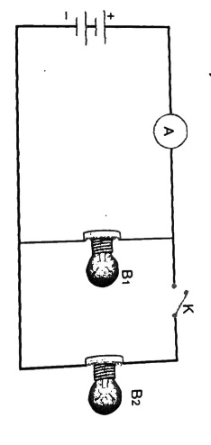

|  |  |  |  |
| --- | --- | --- | --- |
| (a) remain unchanged | (b) be doubled | (c) be halved | (d) become 4 times |

1. A student carries out an experiment and plots the V-I graphs of three samples of nichrome wire with resistances R1 , R2 and R3 respectively, Which of the following is true ?

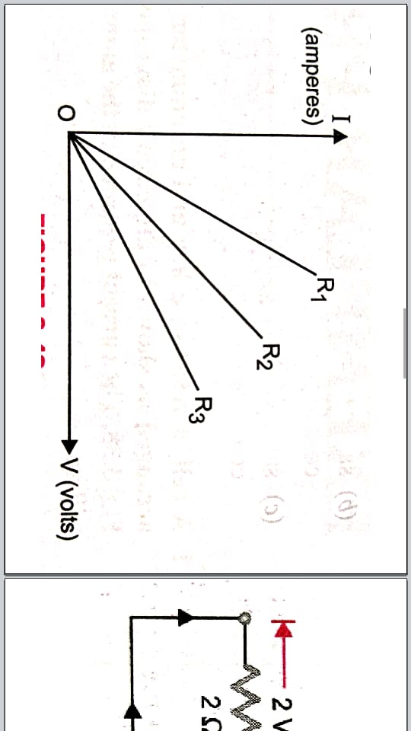

|  |  |  |  |
| --- | --- | --- | --- |
| a) R1 = R2 = R3 | b) R1 > R2 > R3 | c) R3 > R2 > R1 | d) R2 > R3 > R1 |

1. In the following circuits as in figure, heat produced in the resistor or combination of resistor connected to a 12 V battery will be :

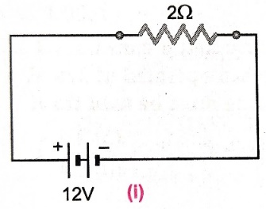 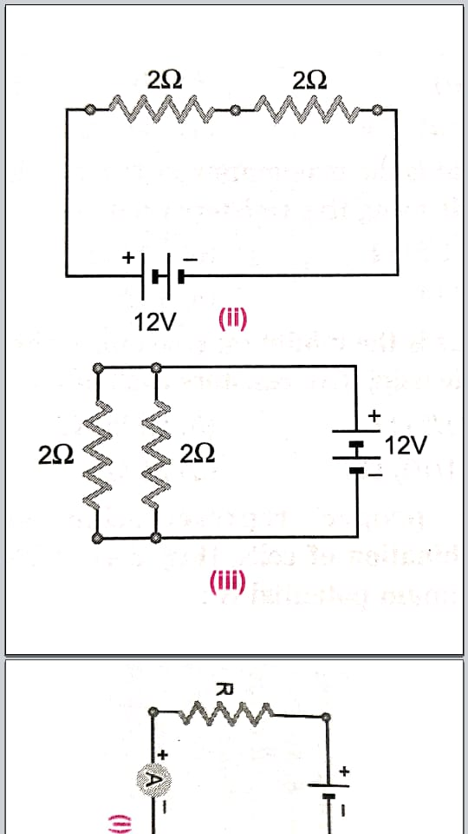 

|  |  |
| --- | --- |
| a) same in all the cases | b) minimum in case (i) |
| c) maximum in case (ii) | d) maximum in case (iii) |

1. The acid having highest hydrogen ion concentration is one with :

|  |  |  |  |
| --- | --- | --- | --- |
| (a) pH = 2.5 | (b) pH = 1.8 | (c) pH = 7 | (d) pH = 10 |

1. The pH of the gastric juices released during digestion is :

|  |  |  |  |
| --- | --- | --- | --- |
| (a) less than 7 | (b) more than 7 | (c) equal to 7 | (d) equal to 0 |

1. In addition to sodium hydrogen carbonate, baking powder contains a substance ‘X’. name the substance ‘X’. [ 1 ]
2. Name the substance obtained by the action of chlorine on dry slaked lime. [ 1 ]
3. Arrange the following in the increasing order of acidic strength : Gastric juice , milk , Lemon juice [ 1 ]
4. What is the resistance of an ideal ammeter? [ 1 ]
5. What is the resistance of an air gap? [ 1 ]
6. What happens when nitric acid is added to an egg shell? [ 1 ]
7. Name the acid present in the following : (a) Tomato (b) Vinegar (c) Tamarind [ 1 ]
8. A given length of wire is doubled on itself and this process is repeated once again. By what factor does the resistance of the wire change? [ 2 ]
9. A wire resistance 20 Ω is bent to form a closed square. What is the resistance across a diagonal of the square?

[ 2 ]

1. A current 5 A is flowing through a resistor of 15 Ω. Calculate the potential difference between the ends of the resistor. [ 2 ]
2. An electric iron has a rating of 750 W , 220 V. Calculate : [ 2 ]

(i) The current passing through it (ii) Its resistance, when in use.

1. An electric refrigerator rated at 400 W operates 8 hr/day. What is the cost of energy to operate it for 30 days at Rs. 3.00 per kWh ? [ 2 ]
2. Calculate the total power of 5 fans if each of them draws a current of 0.8 A at a potential difference of 220 V.

[ 2 ]

1. Find the equivalent resistrance across the two ends A and B of this circuit. [ 3 ]

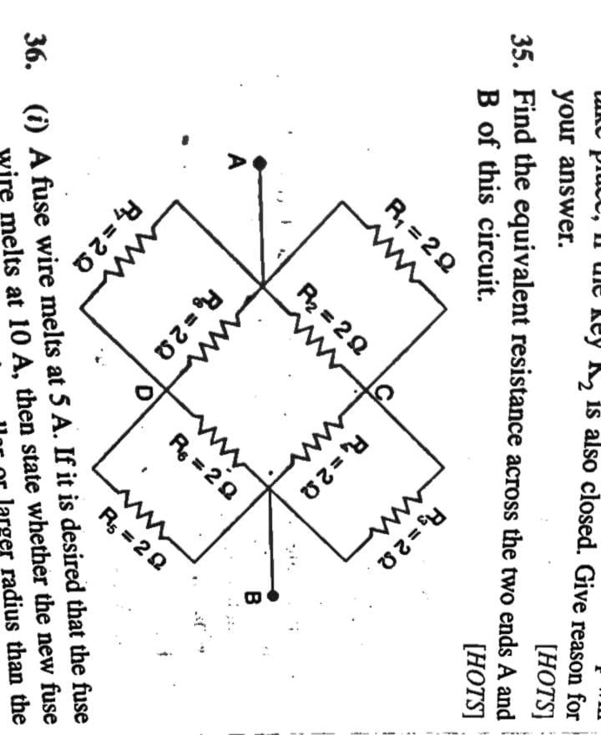

1. (a) Find the value of current ‘I’ in the circuit given below : [ 3 ]

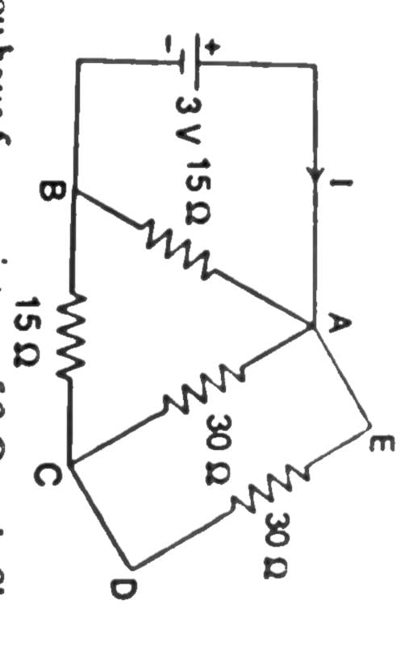

(b) You have 4 resistors of 8 Ω each. Show how would you connect these resistors to have effective resistance of 8 Ω.

**Karan Arora** **M:9416974837**

**I.P.S.Sr.Sec.School**

**Max Time : 1 hr** **Class : 10th Science Max Marks : 30**

**Unit Test Code : B**

1. **Answer the following Multiple Choice Questions :** [ 1 x 5 = 5 ]
2. The acid having highest hydrogen ion concentration is one with :

|  |  |  |  |
| --- | --- | --- | --- |
| (a) pH = 2.5 | (b) pH = 1.8 | (c) pH = 7 | (d) pH = 10 |

1. A student carries out an experiment and plots the V-I graphs of three samples of nichrome wire with resistances R1 , R2 and R3 respectively, Which of the following is true ?



|  |  |  |  |
| --- | --- | --- | --- |
| a) R1 = R2 = R3 | b) R1 > R2 > R3 | c) R3 > R2 > R1 | d) R2 > R3 > R1 |

1. The pH of the gastric juices released during digestion is :

|  |  |  |  |
| --- | --- | --- | --- |
| (a) less than 7 | (b) more than 7 | (c) equal to 7 | (d) equal to 0 |

1. Bulbs B1 and B2 are exactly identical. When the key K is pressed, the reading of the ammeter will.



|  |  |  |  |
| --- | --- | --- | --- |
| (a) remain unchanged | (b) be doubled | (c) be halved | (d) become 4 times |

1. In the following circuits as in figure, heat produced in the resistor or combination of resistor connected to a 12 V battery will be :

  

|  |  |
| --- | --- |
| a) same in all the cases | b) minimum in case (i) |
| c) maximum in case (ii) | d) maximum in case (iii) |

1. What is the resistance of an air gap? [ 1 ]
2. What is the resistance of an ideal ammeter? [ 1 ]
3. Name the substance obtained by the action of chlorine on dry slaked lime. [ 1 ]
4. Name the acid present in the following : (a) Tomato (b) Vinegar (c) Tamarind [ 1 ]
5. In addition to sodium hydrogen carbonate, baking powder contains a substance ‘X’. name the substance ‘X’. [ 1 ]
6. What happens when nitric acid is added to an egg shell? [ 1 ]
7. Arrange the following in the increasing order of acidic strength : Gastric juice , milk , Lemon juice [ 1 ]
8. An electric iron has a rating of 750 W , 220 V. Calculate : [ 2 ]

(i) The current passing through it (ii) Its resistance, when in use.

1. A current 5 A is flowing through a resistor of 15 Ω. Calculate the potential difference between the ends of the resistor. [ 2 ]
2. Calculate the total power of 5 fans if each of them draws a current of 0.8 A at a potential difference of 220 V.

[ 2 ]

1. A wire resistance 20 Ω is bent to form a closed square. What is the resistance across a diagonal of the square?

[ 2 ]

1. An electric refrigerator rated at 400 W operates 8 hr/day. What is the cost of energy to operate it for 30 days at Rs. 3.00 per kWh ? [ 2 ]
2. A given length of wire is doubled on itself and this process is repeated once again. By what factor does the resistance of the wire change? [ 2 ]
3. Find the equivalent resistrance across the two ends A and B of this circuit. [ 3 ]



1. (a) Find the value of current ‘I’ in the circuit given below : [ 3 ]



(b) You have 4 resistors of 8 Ω each. Show how would you connect these resistors to have effective resistance of 8 Ω.